**UE20CS353 - Compiler Design**

**Lab 6**

**Name**: Vishwa Mehul Mehta

**SRN**: PES2UG20CS389

**Sec**: F

**Date**: 24-04-2023

**AST Outputs:**

Test case 1:

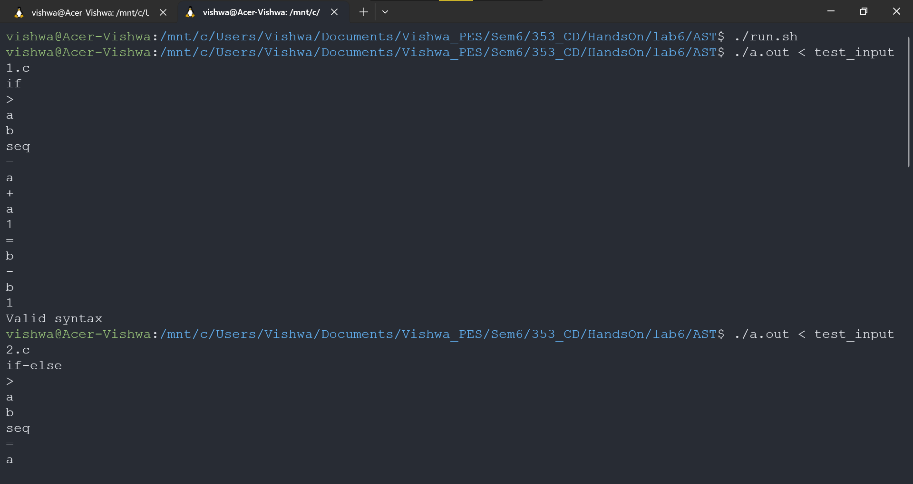

Test case 2:

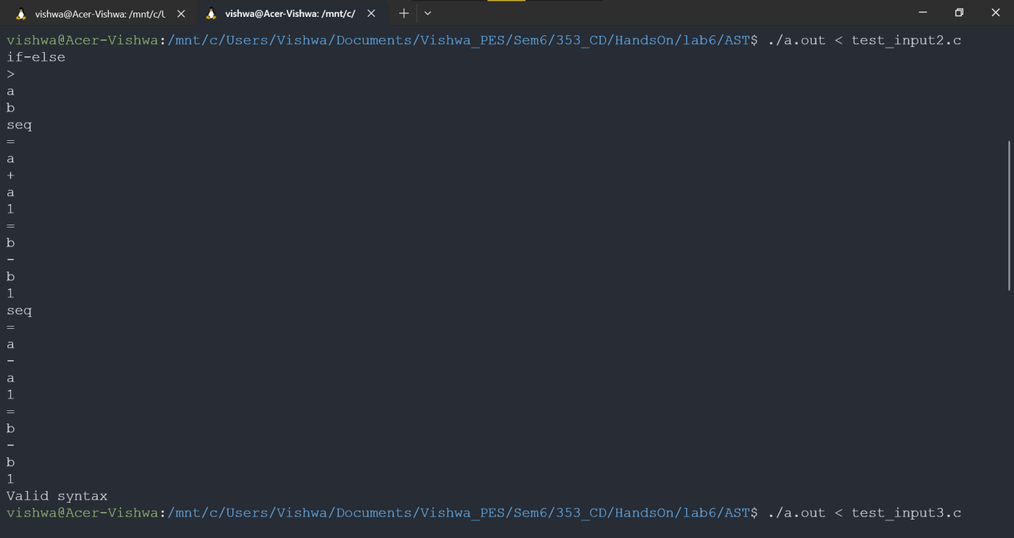

Test case 3:

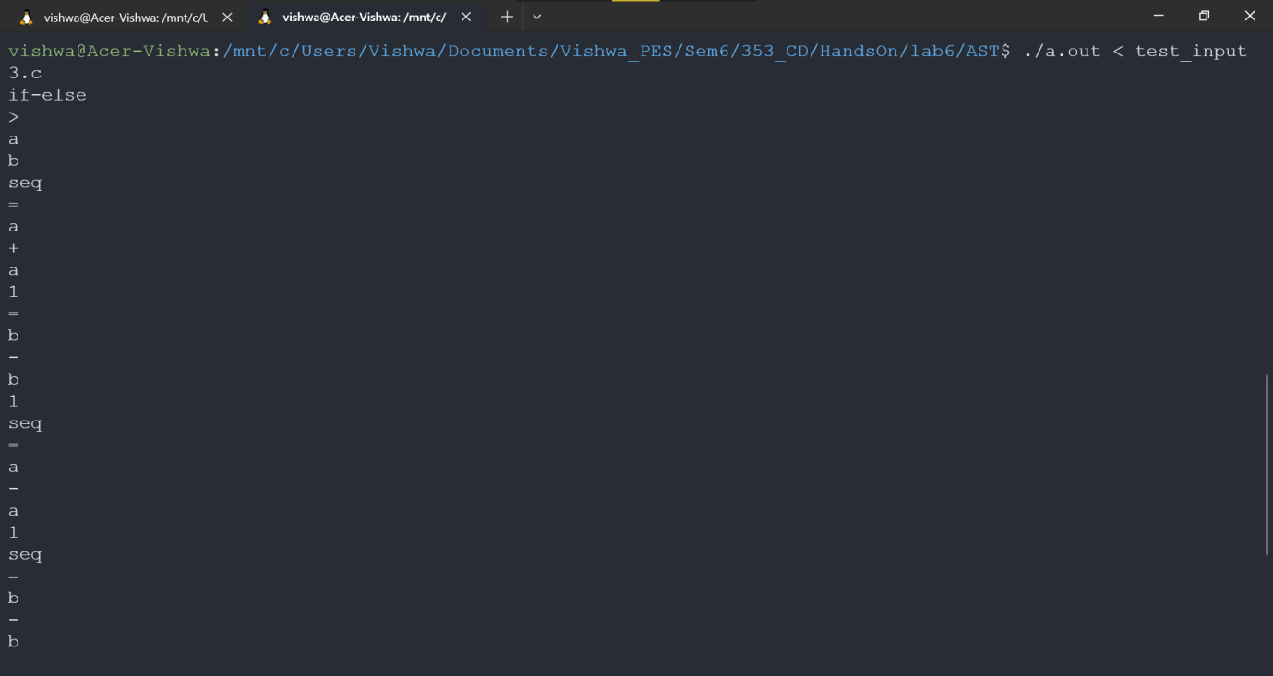

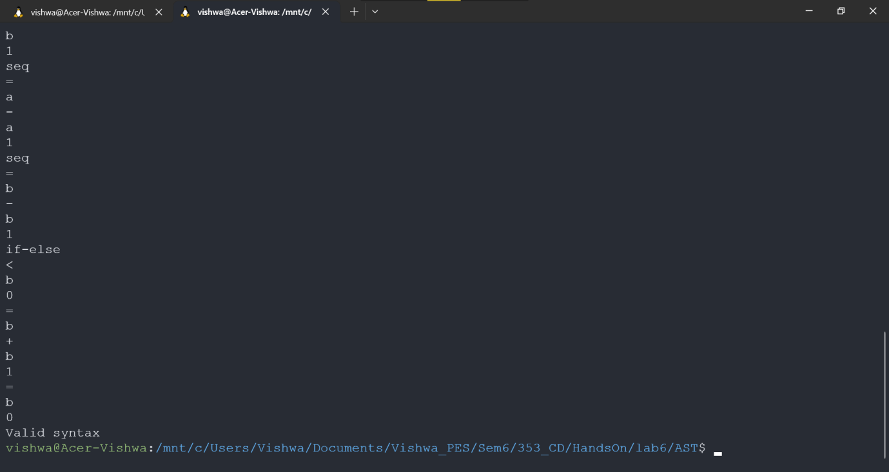

**ICG Outputs:**

Test case 1 and 2:

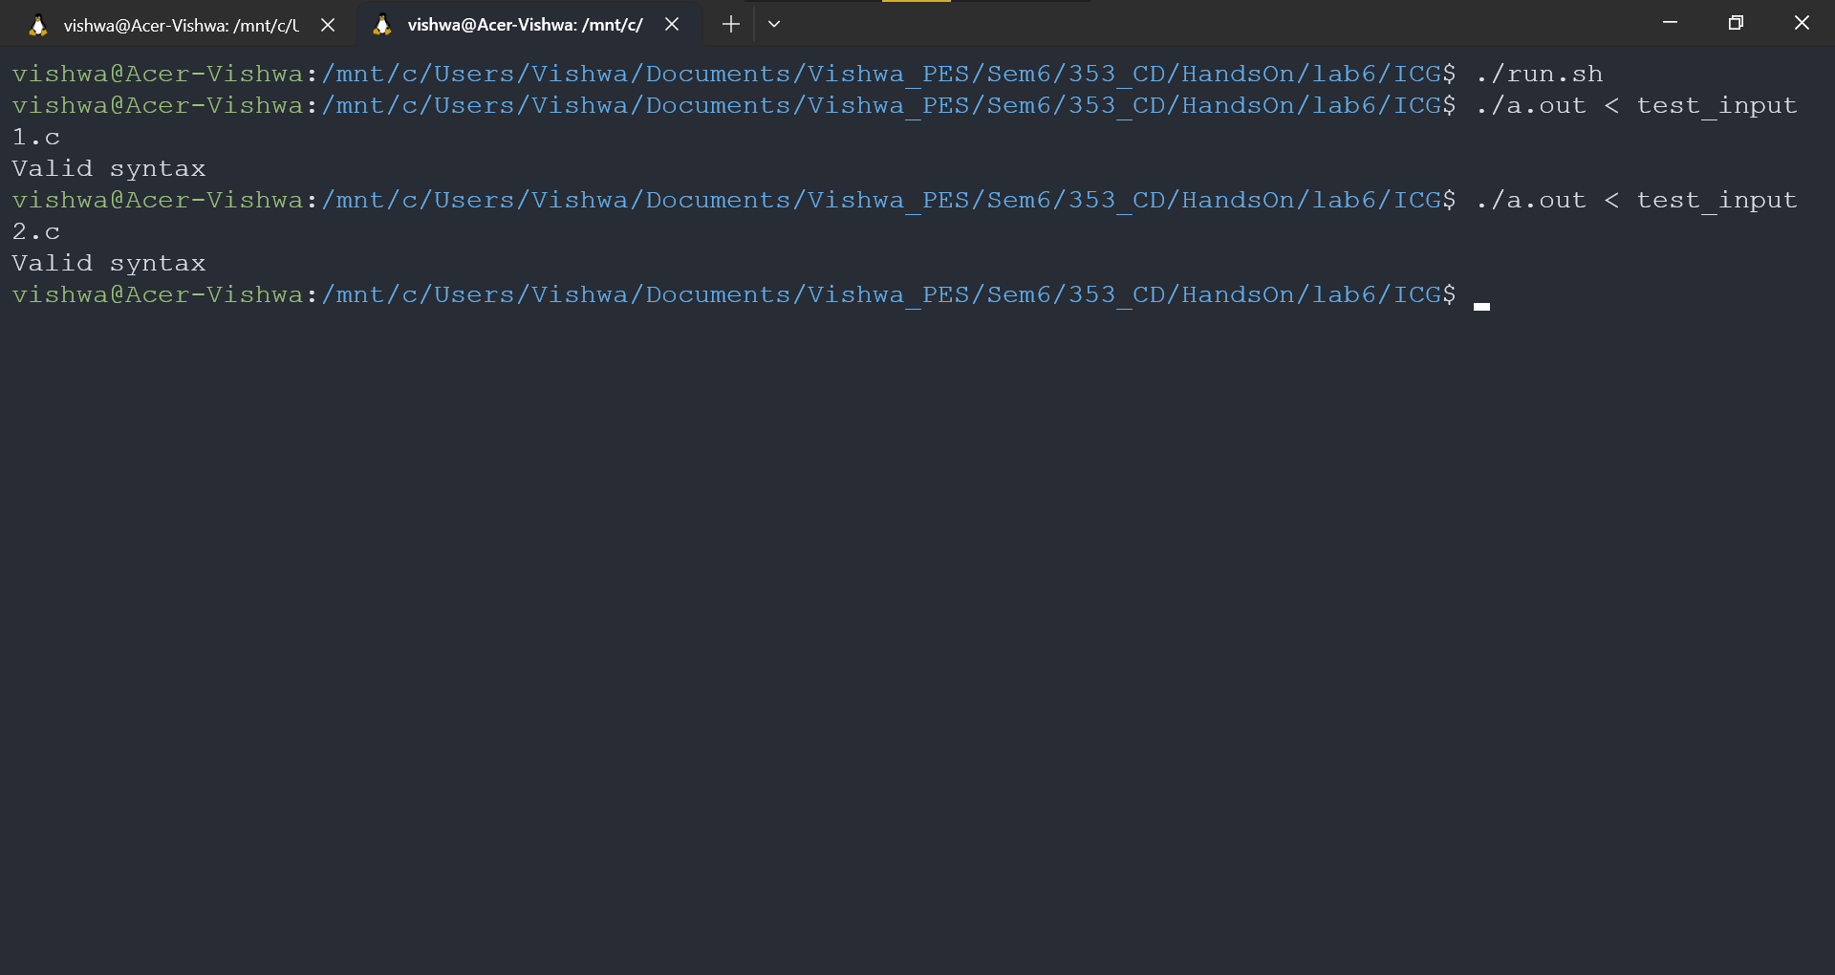

Intermediate Code:

